Abstract

Table of Contents

Table of Figures

Sprint 01

1. Sprint goal

Create a login and registration page with high quality also add edit user information and delete user accounts functions to the home page.

1. Sprint backlog

|  |  |  |  |  |  |
| --- | --- | --- | --- | --- | --- |
| ID | User Story | Tasks | Assigned to | Status | Estimated Effort |
| UC01 | As a Student, I need the LMS to be a user-friendly interface with simple log-in and should be easy to navigate as a first-time user. | Draw a clear activity diagram and use-case diagram | BA | Completed | 12 |
| Design using wireframes | UI/UX Designer | Completed |
| Implement the login system | Developer | Completed |
| UC02 | As a Teacher, I need my account to be protected. So I need to have the facility to change my password. Also, there should be a function to delete my user account | Implement the user delete system | Developer | Completed | 16 |
| Completed |
| UC05 | As an Admin, this LMS should have a database that prioritize data privacy and security, I need to add students and teachers to the system with ensuring that student and teacher information is kept confidential and protected. | Research a database solution to store the user information | Project Manager | Completed | 20 |
| Implement the database | Developer | Completed |
| Conduct some tests to ensure the implementation is working | QA Engineer | Completed |
| UC07 | As a Student, I need to edit my user information whenever I need. Specially password. | Draw the wireframes of the designs | UI/UX Engineer | Completed | 24 |
| Implement a simple user edit functionality | Developer | Completed |
|  |  |  |  |  |  |

1. Sprint Roles

Amindu Weerawardhana - Project Manager/ Developer

Virantha Kapuliyadda - Business Analyst

Mihika Pathirana – UI/UX Developer

Oshadhi Weerathunga – QA Engineer

Detailed Use Case Diagrams /Use case Specifications and activity diagrams

Figure 1 Use Case Diagram

Use case scenarios

|  |  |
| --- | --- |
| Use Case Name | Login |
| Description | Allows the student to login to their workspace |
| Primary Actor | Student |
| Pre-Conditions | Student should register with the system by using unique username and password |
| Basic Flow | 1. Use Case begins when the student clicks on the login button from the navigation bar.  2. The system redirects the user to home page if user entered the valid credentials.  Credentials are checked with the database. |
| Extensions | If the user details are invalid  1. System display message “Invalid Credentials”  2. Use case ends |
| Post Conditions | The user can view the home page |
| Optional Information | - |

|  |  |
| --- | --- |
| Use Case Name | Login |
| Description | Allows the student to login to their workspace |
| Primary Actor | Student |
| Pre-Conditions | Student should register with the system by using unique username and password |
| Basic Flow | 1. Use Case begins when the student clicks on the login button from the navigation bar.  2. The system redirects the user to home page if user entered the valid credentials.  Credentials are checked with the database. |
| Extensions | If the user details are invalid  1. System display message “Invalid Credentials”  2. Use case ends |
| Post Conditions | The user can view the home page |
| Optional Information | - |

|  |  |
| --- | --- |
| Use case name | Login |
| Description | Allows the teacher to login to the system |
| Primary actor | Teacher |
| Pre-conditions | Teacher should register with the system using a unique username and password |
| Basic flow | 1. Use Case begins when the teacher clicks on the login button from the navigation bar.  2. The system redirects the user to home page if user entered the valid credentials.  Credentials are checked with the database. |
| Extensions | If the user details are invalid  1. System display message “Invalid Credentials”  2. Use case ends |
| Post Conditions | The user can view the home page |

|  |  |
| --- | --- |
| Use case name | Login |
| Description | Allows the Admin to login to the admin dashboard |
| Primary actor | Admin |
| Pre-conditions | Admin register with the system using a unique username and password |
| Basic flow | 1. Use Case begins when the admin clicks on the login button from the navigation bar.  2. The system redirects the user to home page if user entered the valid credentials.  Credentials are checked with the database. |
| Extensions | If the user details are invalid  1. System display message “Invalid Credentials”  2. Use case ends |
| Post Conditions | The user can view the admin dashboard |

|  |  |
| --- | --- |
| Use case name | Edit user information |
| Description | Allows the teacher to edit their information |
| Primary actor | Teacher |
| Pre-conditions | Teacher should log into the system |
| Basic flow | Use case begins when the teacher clicks on the edit info button from the navigation bar.  The system will retrieve the information of logged in user from the database and user can edit them |
| Extensions | If some user details are invalid system displays an error message.  Use case ends. |
| Post Conditions | The user can view the edit info page |

|  |  |
| --- | --- |
| Use case name | Delete user account |
| Description | Allows the teacher to delete their accounts |
| Primary actor | Teacher |
| Pre-conditions | Teacher should log into the system |
| Basic flow | Use case begins when the teacher clicks on the delete account button from the navigation bar.  The system will delete the information of that user from the database |
| Extensions | - |
| Post Conditions | The user can view the first page |

|  |  |
| --- | --- |
| Use case name | Edit user information |
| Description | Allows the student to edit their information |
| Primary actor | student |
| Pre-conditions | Student should log into the system |
| Basic flow | Use case begins when the student clicks on the edit info button from the navigation bar.  The system will retrieve the information of logged in user from the database and user can edit them |
| Extensions | If some user details are invalid system displays an error message.  Use case ends. |
| Post Conditions | The user can view the edit info page |

|  |  |
| --- | --- |
| Use case name | Delete user account |
| Description | Allows the student to delete their accounts |
| Primary actor | Student |
| Pre-conditions | Student should log into the system |
| Basic flow | Use case begins when the student clicks on the delete account button from the navigation bar.  The system will delete the information of that user from the database |
| Extensions | - |
| Post Conditions | The user can view the first page |

|  |  |
| --- | --- |
| Use case name | View user information |
| Description | Allows the Admin to view user information |
| Primary actor | Admin |
| Pre-conditions | Admin should log into the admin dashboard |
| Basic flow | Use case begins when the admin clicks on the user info button from the navigation bar.  The system will retrieve the information of users from the database |
| Extensions | - |
| Post Conditions | The user can view the user info page |

|  |  |
| --- | --- |
| Use case name | Add users to the system (Teachers/Students) |
| Description | Allows the Admin to add users to the system |
| Primary actor | Admin |
| Pre-conditions | Admin should log into the admin dashboard |
| Basic flow | Use case begins when the admin clicks on the add students/add teachers’ buttons from the navigation bar.  The system will add the information of users to the database |
| Extensions | - |
| Post Conditions | The users been added to the system |

Activity diagrams

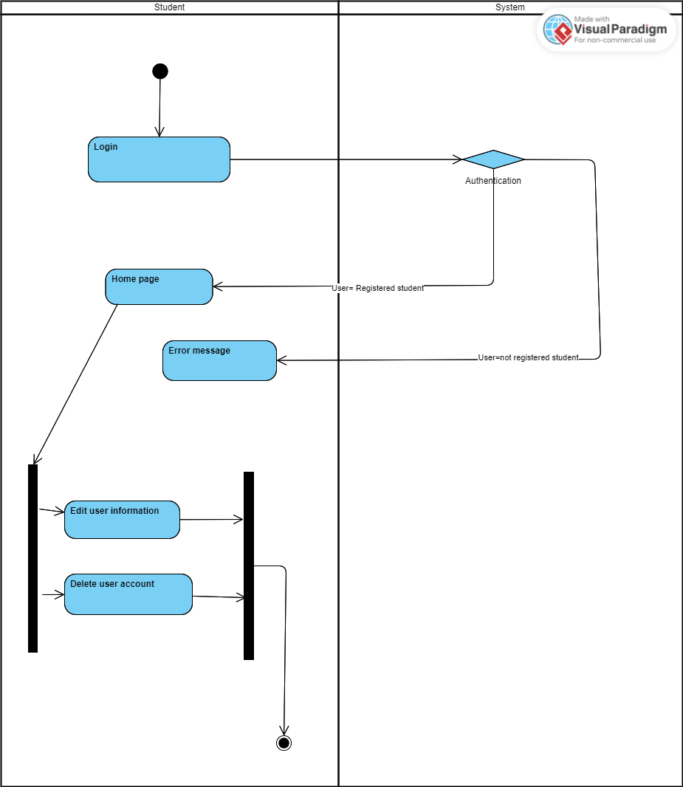

Figure 2 Activity diagram for student

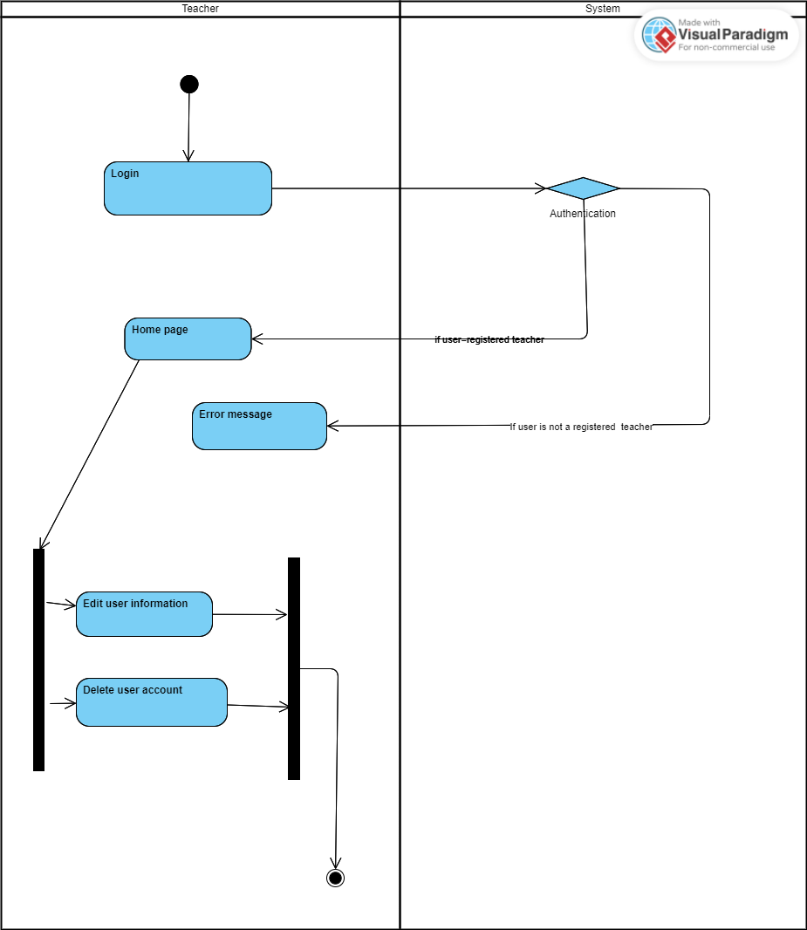

Figure 3 Activity diagram for teacher

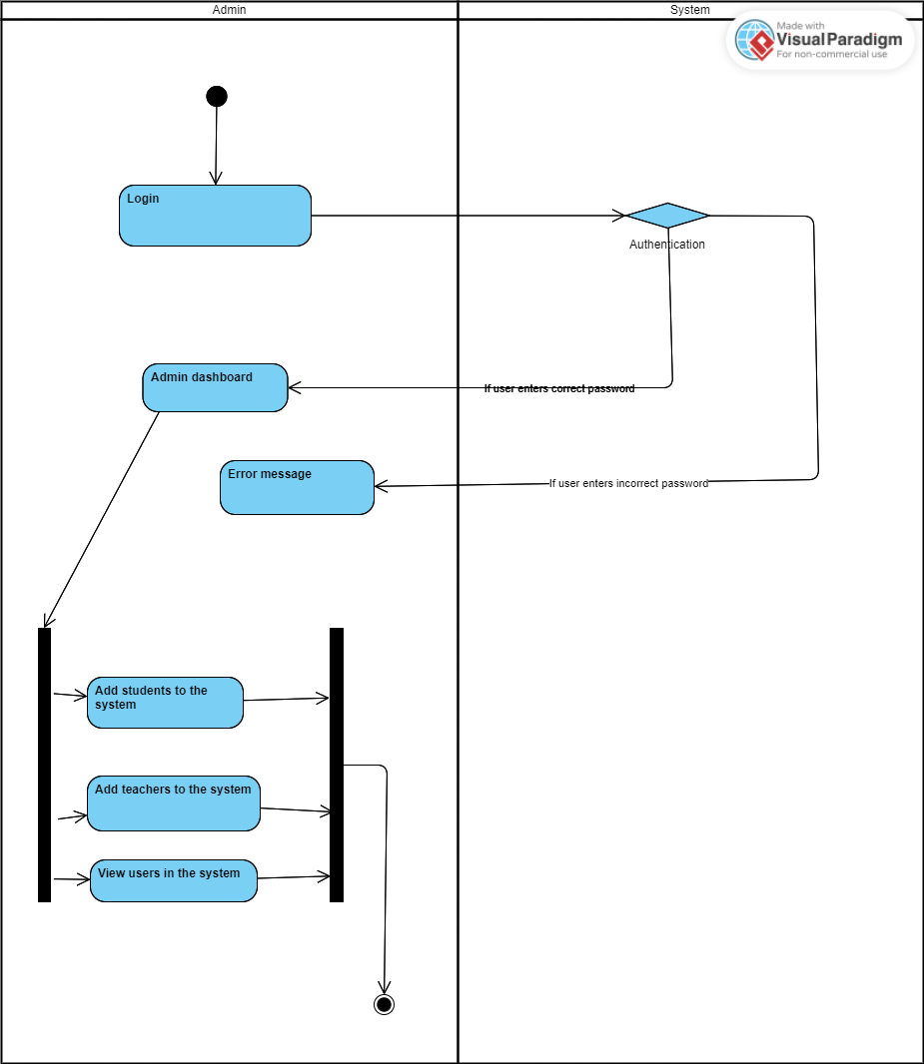

Figure 4 Activity diagram for Admin

1. Implementation(wireframes)

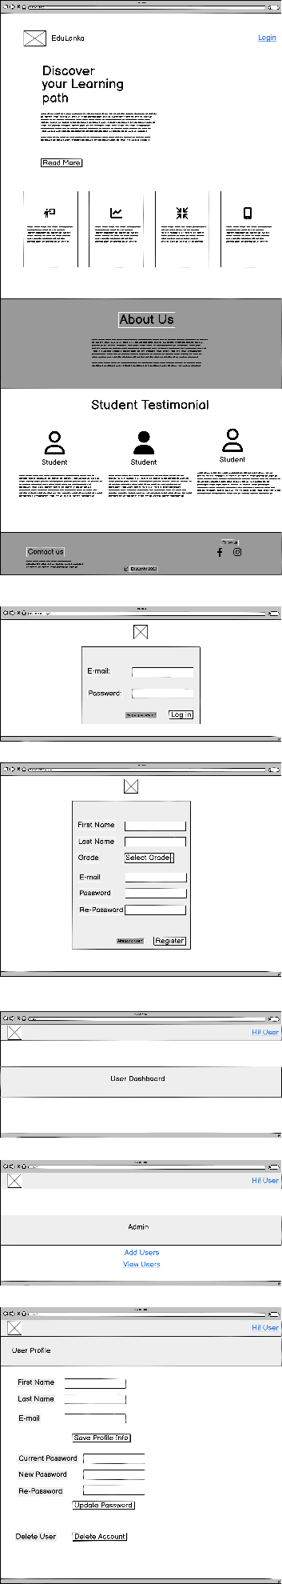

1. Interfaces

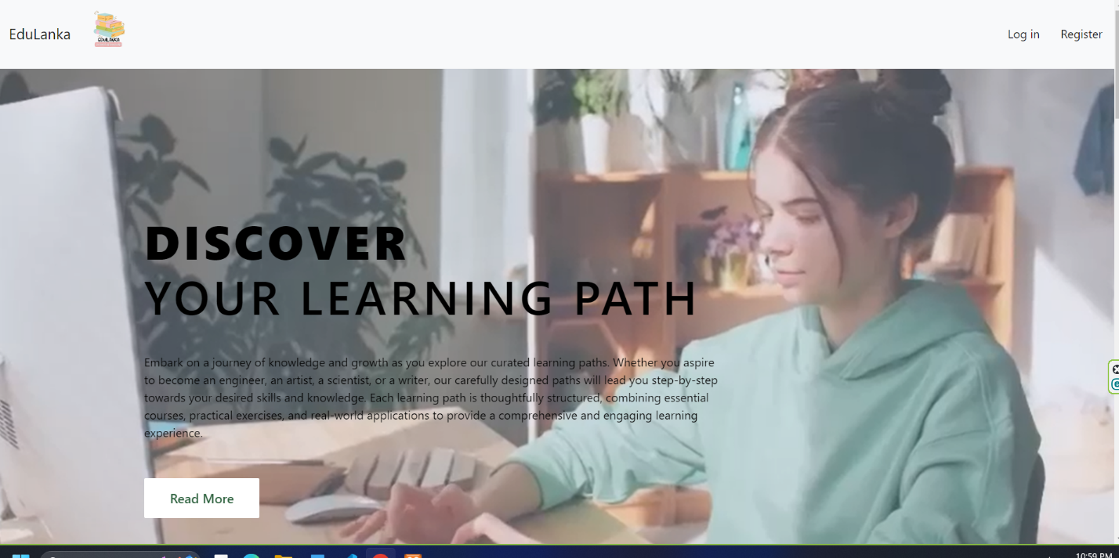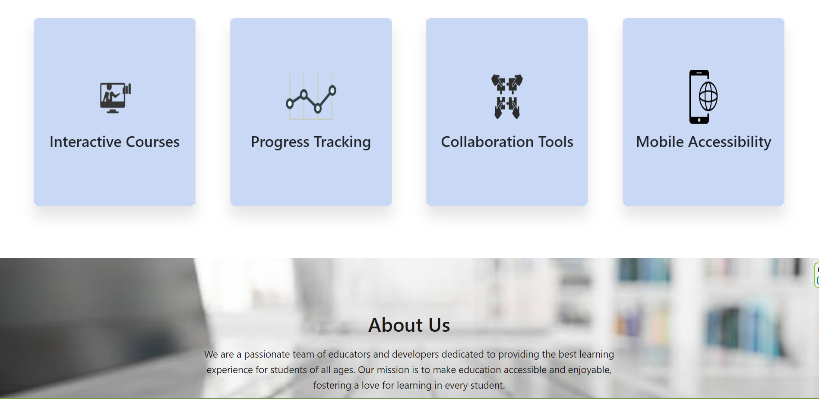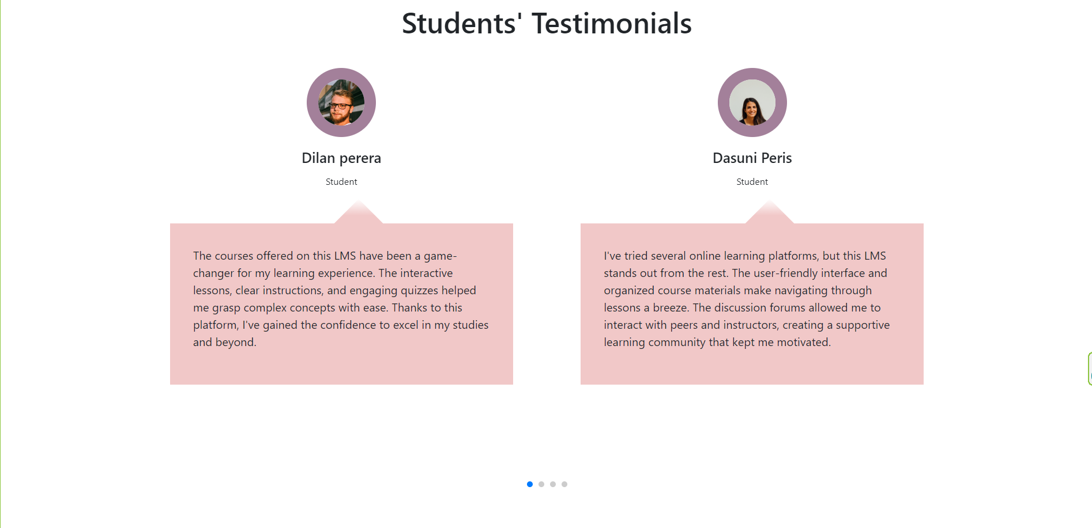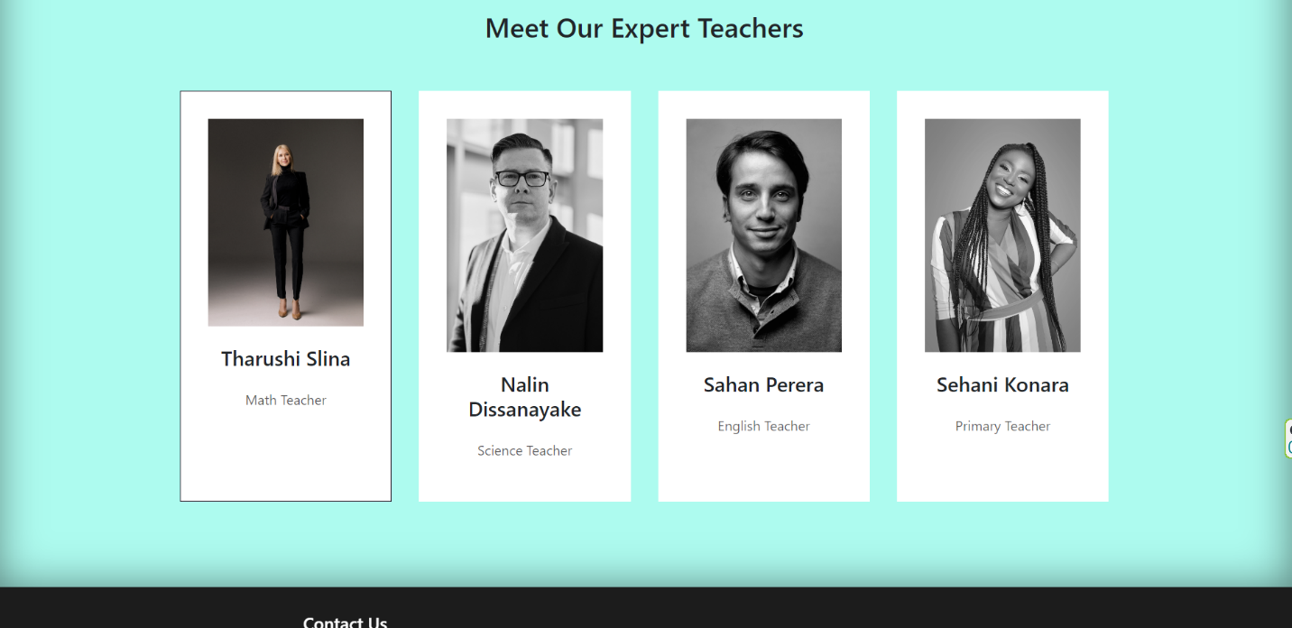

1. Test Cases

|  |  |  |  |  |  |  |  |  |  |  |
| --- | --- | --- | --- | --- | --- | --- | --- | --- | --- | --- |
| **Test Scenario ID** | | Login-S | | | **Test Case ID** | | | Login-S6 | | |
| **Test Case Description** | | Login for students | | | **Test Priority** | | | High | | |
| **Pre-Requisite** | | A valid user account/NA | | | **Post-Requisite** | | | NA | | |
| Test Execution Steps:  Using an already registered student account, enter the false login credentials at first. If user does not get the student view, enter the correct credentials. If user passes to the dashboard, try changing the password. Then log out, and try to log in with the changed password. If user passes to the dashboard, try deleting account. After confirming deletion, if user goes back to dashboard, try to log in using deleted account. Also check the database to confirm that user is removed. | | | | | | | | | | | |
| **S.No** | **Action** | | **Inputs** | **Expected Output** | | **Actual Output** | **Test Browser** | | **Test Result** | **Test Comments** | |
| 1 | Enter correct Email & Password and hit login button | | Email  Password | Logging in to student dashboard | | Same as expected | Opera GX | |  |  | |
| 2 | Enter invalid Email & any Password and hit login button | | Email  Password | Credentials does not match the records | | Same as expected | Opera GX | |  |  | |
| 3 | Enter valid Email & incorrect Password and hit login button | | Email  Password | Credentials does not match the records | | Same as expected | Opera GX | |  |  | |
| 4 | Edit user password and click the save button | | Password | Password changed successfully message, and the password is changed | | Password changes, but the message is not popping up | Opera GX | |  |  | |
| 5 | Delete user account and click the delete button | | Delete button | Delete confirmation pop up, and after confirmation, navigates back to login form | | Same as expected | Opera GX | |  |  | |

|  |  |  |  |  |  |  |  |  |  |  |
| --- | --- | --- | --- | --- | --- | --- | --- | --- | --- | --- |
| **Test Scenario ID** | | Login-T | | | **Test Case ID** | | | Login-T6 | | |
| **Test Case Description** | | Login for Teachers | | | **Test Priority** | | | High | | |
| **Pre-Requisite** | | A valid user account/NA | | | **Post-Requisite** | | | NA | | |
| Test Execution Steps:  Using an already registered teacher account, enter the false login credentials at first. If user does not get the student view, enter the correct credentials. If user passes to the dashboard, try changing the password. Then log out, and try to log in with the changed password. If user passes to the dashboard, try deleting account. After confirming deletion, if user goes back to dashboard, try to log in using deleted account. Also check the database to confirm that user is removed. | | | | | | | | | | | |
| **S.No** | **Action** | | **Inputs** | **Expected Output** | | **Actual Output** | **Test Browser** | | **Test Result** | **Test Comments** | |
| 1 | Enter correct Email & Password and hit login button | | Email  Password | Logging in to teacher dashboard | | Same as expected | Opera GX | | Pass |  | |
| 2 | Enter invalid Email & any Password and hit login button | | Email  Password | Credentials does not match the records | | Same as expected | Opera GX | | Pass |  | |
| 3 | Enter valid Email & incorrect Password and hit login button | | Email  Password | Credentials does not match the records | | Same as expected | Opera GX | | Pass |  | |
| 4 | Edit user password and click the save button | | Password | Password changed successfully message, and the password is changed | | Password changes, but the message is not popping up | Opera GX | | Need to improve |  | |
| 5 | Delete user account and click the delete button | | Delete button | Delete confirmation pop up, and after confirmation, navigates back to login form | | Same as expected | Opera GX | | Need to improve |  | |

|  |  |  |  |  |  |  |  |  |  |  |
| --- | --- | --- | --- | --- | --- | --- | --- | --- | --- | --- |
| **Test Scenario ID** | | Login-A | | | **Test Case ID** | | | Login-AL1 | | |
| **Test Case Description** | | Login for Admin | | | **Test Priority** | | | High | | |
| **Pre-Requisite** | | A valid user account/NA | | | **Post-Requisite** | | | NA | | |
| Test Execution Steps:  Using an already registered admin account, enter the false login credentials at first. If user does not get the student view, enter the correct credentials. If user passes to the dashboard, try changing the password. Then log out, and try to log in with the changed password. If user passes to the dashboard, try deleting account. After confirming deletion, if user goes back to dashboard, try to log in using deleted account. Also check the database to confirm that user is removed.  And in the admin dashboard, click the register user button to see whether admin can navigate to the user registration form. Also click the view users button to see whether admin can view all users saved in the database. | | | | | | | | | | | |
| **S.No** | **Action** | | **Inputs** | **Expected Output** | | **Actual Output** | **Test Browser** | | **Test Result** | **Test Comments** | |
| 1 | Enter correct Email & Password and hit login button | | Email  Password | Logging in to admin dashboard | | Same as expected | Opera  GX | | Pass |  | |
| 2 | Enter invalid Email & any Password and hit login button | | Email  Password | Credentials does not match the records | | Same as expected | Opera  GX | | Pass |  | |
| 3 | Enter valid Email & incorrect Password and hit login button | | Email  Password | Credentials does not match the records | | Same as expected | Opera  GX | | Pass |  | |
| 4 | View user registration form by clicking the button | | View register form button | View user registration form | | Same as expected | Opera  GX | | Pass |  | |
| 5 | Add teachers and Students to the system and click the register button | | First Name  Last Name  User type(Grade for students/ Admin and Teacher have 0 and 1 user types respectively)  E-mail  Password | User registers, and user data is saved in the database, user navigates back to admin dashboard | | User data is not saving in the database due to a problem in the default route, but after clicking the button, user navigates to the admin page back | Opera  GX | | Need to improve |  | |
| 6 | View user information  Click view user button | | View all users button | View all users in a table | | Same as expected | Opera  GX | | Pass |  | |
| 7 | Edit user password  and click the save button | | Password | Password changed successfully message, and the password is changed | | Password changes, but the message is not popping up | Opera GX | | Need to improve |  | |
| 8 | Delete user account and click the delete button | | Delete button | Delete confirmation pop up, and after confirmation, navigates back to login form | | Same as expected | Opera GX | | Pass |  | |

1. Workload matrix
2. Sprint Retrospective